Week 2 – Project
Task 1
Screenshot  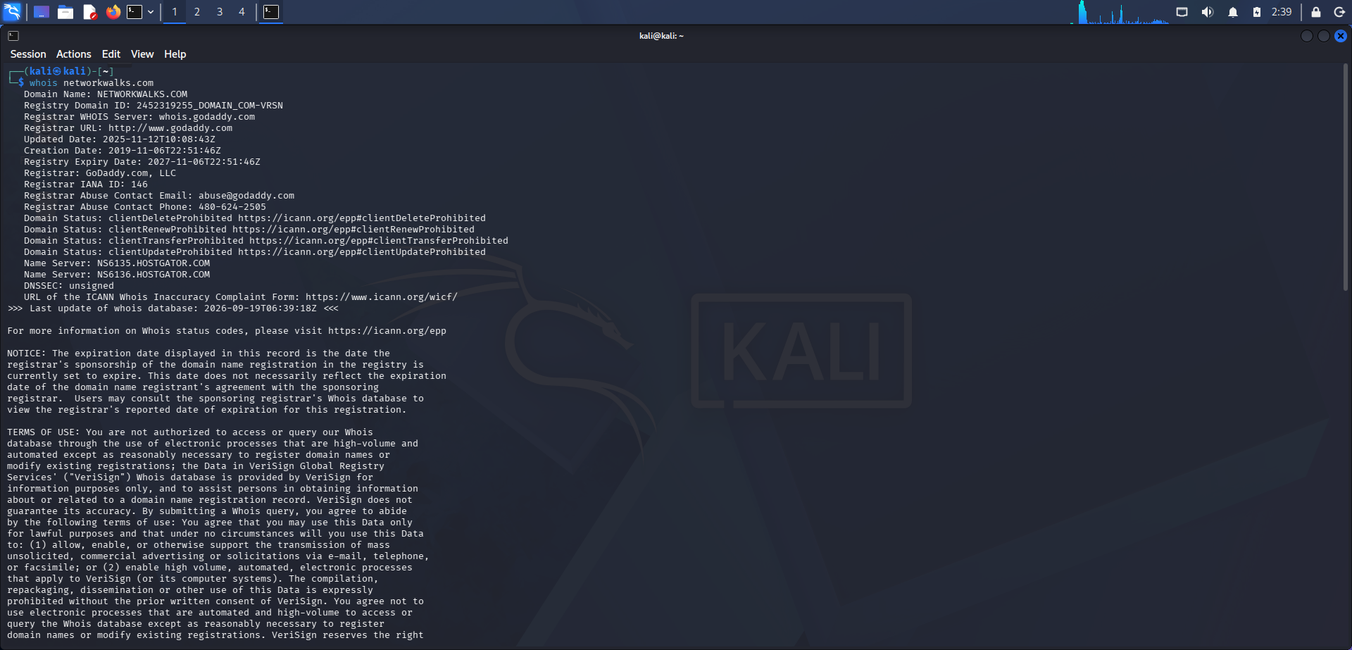 | Output file  ┌──(kali㉿kali)-[~]  └─$ whois networkwalks.com  Domain Name: NETWORKWALKS.COM  Registry Domain ID: 2452319255_DOMAIN_COM-VRSN  Registrar WHOIS Server: whois.godaddy.com  Registrar URL: http://www.godaddy.com  Updated Date: 2025-11-12T10:08:43Z  Creation Date: 2019-11-06T22:51:46Z  Registry Expiry Date: 2027-11-06T22:51:46Z  Registrar: GoDaddy.com, LLC  Registrar IANA ID: 146  Registrar Abuse Contact Email: abuse@godaddy.com  Registrar Abuse Contact Phone: 480-624-2505  Domain Status: clientDeleteProhibited https://icann.org/epp#clientDeleteProhibited  Domain Status: clientRenewProhibited https://icann.org/epp#clientRenewProhibited  Domain Status: clientTransferProhibited https://icann.org/epp#clientTransferProhibited  Domain Status: clientUpdateProhibited https://icann.org/epp#clientUpdateProhibited  Name Server: NS6135.HOSTGATOR.COM  Name Server: NS6136.HOSTGATOR.COM  DNSSEC: unsigned  URL of the ICANN Whois Inaccuracy Complaint Form: https://www.icann.org/wicf/  >>> Last update of whois database: 2026-09-19T06:34:03Z <<<  For more information on Whois status codes, please visit https://icann.org/epp  NOTICE: The expiration date displayed in this record is the date the  registrar's sponsorship of the domain name registration in the registry is  currently set to expire. This date does not necessarily reflect the expiration  date of the domain name registrant's agreement with the sponsoring  registrar. Users may consult the sponsoring registrar's Whois database to  view the registrar's reported date of expiration for this registration.  TERMS OF USE: You are not authorized to access or query our Whois  database through the use of electronic processes that are high-volume and  automated except as reasonably necessary to register domain names or  modify existing registrations; the Data in VeriSign Global Registry  Services' ("VeriSign") Whois database is provided by VeriSign for  information purposes only, and to assist persons in obtaining information  about or related to a domain name registration record. VeriSign does not  guarantee its accuracy. By submitting a Whois query, you agree to abide  by the following terms of use: You agree that you may use this Data only  for lawful purposes and that under no circumstances will you use this Data  to: (1) allow, enable, or otherwise support the transmission of mass  unsolicited, commercial advertising or solicitations via e-mail, telephone,  or facsimile; or (2) enable high volume, automated, electronic processes  that apply to VeriSign (or its computer systems). The compilation,  repackaging, dissemination or other use of this Data is expressly  prohibited without the prior written consent of VeriSign. You agree not to  use electronic processes that are automated and high-volume to access or  query the Whois database except as reasonably necessary to register  domain names or modify existing registrations. VeriSign reserves the right  to restrict your access to the Whois database in its sole discretion to ensure  operational stability. VeriSign may restrict or terminate your access to the  Whois database for failure to abide by these terms of use. VeriSign  reserves the right to modify these terms at any time.  The Registry database contains ONLY .COM, .NET, .EDU domains and  Registrars.  Domain Name: networkwalks.com  Registry Domain ID: 2452319255_DOMAIN_COM-VRSN  Registrar WHOIS Server: whois.godaddy.com  Registrar URL: https://www.godaddy.com  Updated Date: 2025-11-12T05:08:41Z  Creation Date: 2019-11-06T17:51:46Z  Registrar Registration Expiration Date: 2027-11-06T17:51:46Z  Registrar: GoDaddy.com, LLC  Registrar IANA ID: 146  Registrar Abuse Contact Email: abuse@godaddy.com  Registrar Abuse Contact Phone: +1.4806242505  Domain Status: clientTransferProhibited https://icann.org/epp#clientTransferProhibited  Domain Status: clientUpdateProhibited https://icann.org/epp#clientUpdateProhibited  Domain Status: clientRenewProhibited https://icann.org/epp#clientRenewProhibited  Domain Status: clientDeleteProhibited https://icann.org/epp#clientDeleteProhibited  Registry Registrant ID: Not Available From Registry  Registrant Name: Registration Private  Registrant Organization: Domains By Proxy, LLC  Registrant Street: DomainsByProxy.com  Registrant Street: 100 S. Mill Ave, Suite 1600  Registrant City: Tempe  Registrant State/Province: Arizona  Registrant Postal Code: 85281  Registrant Country: US  Registrant Phone: +1.4806242599  Registrant Phone Ext:  Registrant Fax:  Registrant Fax Ext:  Registrant Email: https://www.godaddy.com/whois/results.aspx?domain=networkwalks.com&action=contactDomainOwner  Registry Tech ID: Not Available From Registry  Tech Name: Registration Private  Tech Organization: Domains By Proxy, LLC  Tech Street: DomainsByProxy.com  Tech Street: 100 S. Mill Ave, Suite 1600  Tech City: Tempe  Tech State/Province: Arizona  Tech Postal Code: 85281  Tech Country: US  Tech Phone: +1.4806242599  Tech Phone Ext:  Tech Fax:  Tech Fax Ext:  Tech Email: https://www.godaddy.com/whois/results.aspx?domain=networkwalks.com&action=contactDomainOwner  Name Server: NS6135.HOSTGATOR.COM  Name Server: NS6136.HOSTGATOR.COM  Name Server: NS29.DOMAINCONTROL.COM  Name Server: NS30.DOMAINCONTROL.COM  DNSSEC: unsigned  URL of the ICANN WHOIS Data Problem Reporting System: http://wdprs.internic.net/  >>> Last update of WHOIS database: 2026-09-19T06:34:10Z <<<  For more information on Whois status codes, please visit https://icann.org/epp  TERMS OF USE: The data contained in this registrar's Whois database, while believed by the  registrar to be reliable, is provided "as is" with no guarantee or warranties regarding its  accuracy. This information is provided for the sole purpose of assisting you in obtaining  information about domain name registration records. Any use of this data for any other purpose  is expressly forbidden without the prior written permission of this registrar. By submitting  an inquiry, you agree to these terms and limitations of warranty. In particular, you agree not  to use this data to allow, enable, or otherwise support the dissemination or collection of this  data, in part or in its entirety, for any purpose, such as transmission by e-mail, telephone,  postal mail, facsimile or other means of mass unsolicited, commercial advertising or solicitations  of any kind, including spam. You further agree not to use this data to enable high volume, automated  or robotic electronic processes designed to collect or compile this data for any purpose, including  mining this data for your own personal or commercial purposes. Failure to comply with these terms  may result in termination of access to the Whois database. These terms may be subject to modification  at any time without notice.  **NOTICE** This WHOIS server is being retired. Please use our RDAP service instead.
Task 2
Screenshot  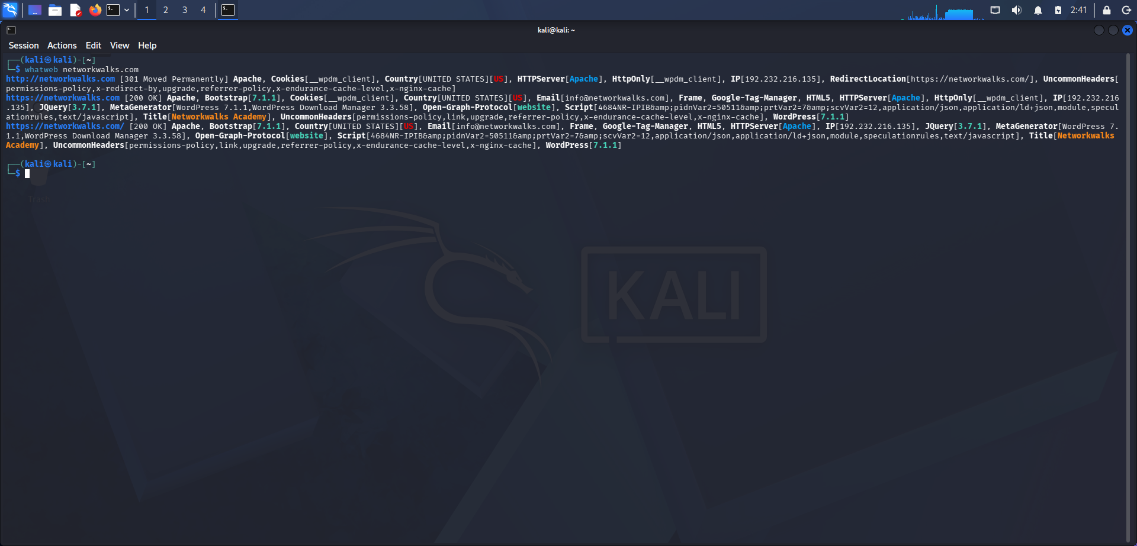 | Output file  ┌──(kali㉿kali)-[~]  └─$ whatweb networkwalks.com  http://networkwalks.com [301 Moved Permanently] Apache, Cookies[__wpdm_client], Country[UNITED STATES][US], HTTPServer[Apache], HttpOnly[__wpdm_client], IP[192.232.216.135], RedirectLocation[https://networkwalks.com/], UncommonHeaders[permissions-policy,x-redirect-by,upgrade,referrer-policy,x-endurance-cache-level,x-nginx-cache]  https://networkwalks.com [200 OK] Apache, Bootstrap[7.1.1], Cookies[__wpdm_client], Country[UNITED STATES][US], Email[info@networkwalks.com], Frame, Google-Tag-Manager, HTML5, HTTPServer[Apache], HttpOnly[__wpdm_client], IP[192.232.216.135], JQuery[3.7.1], MetaGenerator[WordPress 7.1.1,WordPress Download Manager 3.3.58], Open-Graph-Protocol[website], Script[4684NR-IPIB&amp;pidnVar2=50511&amp;prtVar2=7&amp;scvVar2=12,application/json,application/ld+json,module,speculationrules,text/javascript], Title[Networkwalks Academy], UncommonHeaders[permissions-policy,link,upgrade,referrer-policy,x-endurance-cache-level,x-nginx-cache], WordPress[7.1.1]  https://networkwalks.com/ [200 OK] Apache, Bootstrap[7.1.1], Country[UNITED STATES][US], Email[info@networkwalks.com], Frame, Google-Tag-Manager, HTML5, HTTPServer[Apache], IP[192.232.216.135], JQuery[3.7.1], MetaGenerator[WordPress 7.1.1,WordPress Download Manager 3.3.58], Open-Graph-Protocol[website], Script[4684NR-IPIB&amp;pidnVar2=50511&amp;prtVar2=7&amp;scvVar2=12,application/json,application/ld+json,module,speculationrules,text/javascript], Title[Networkwalks Academy], UncommonHeaders[permissions-policy,link,upgrade,referrer-policy,x-endurance-cache-level,x-nginx-cache], WordPress[7.1.1]  ┌──(kali㉿kali)-[~]  └─$
Task 3
Screenshot  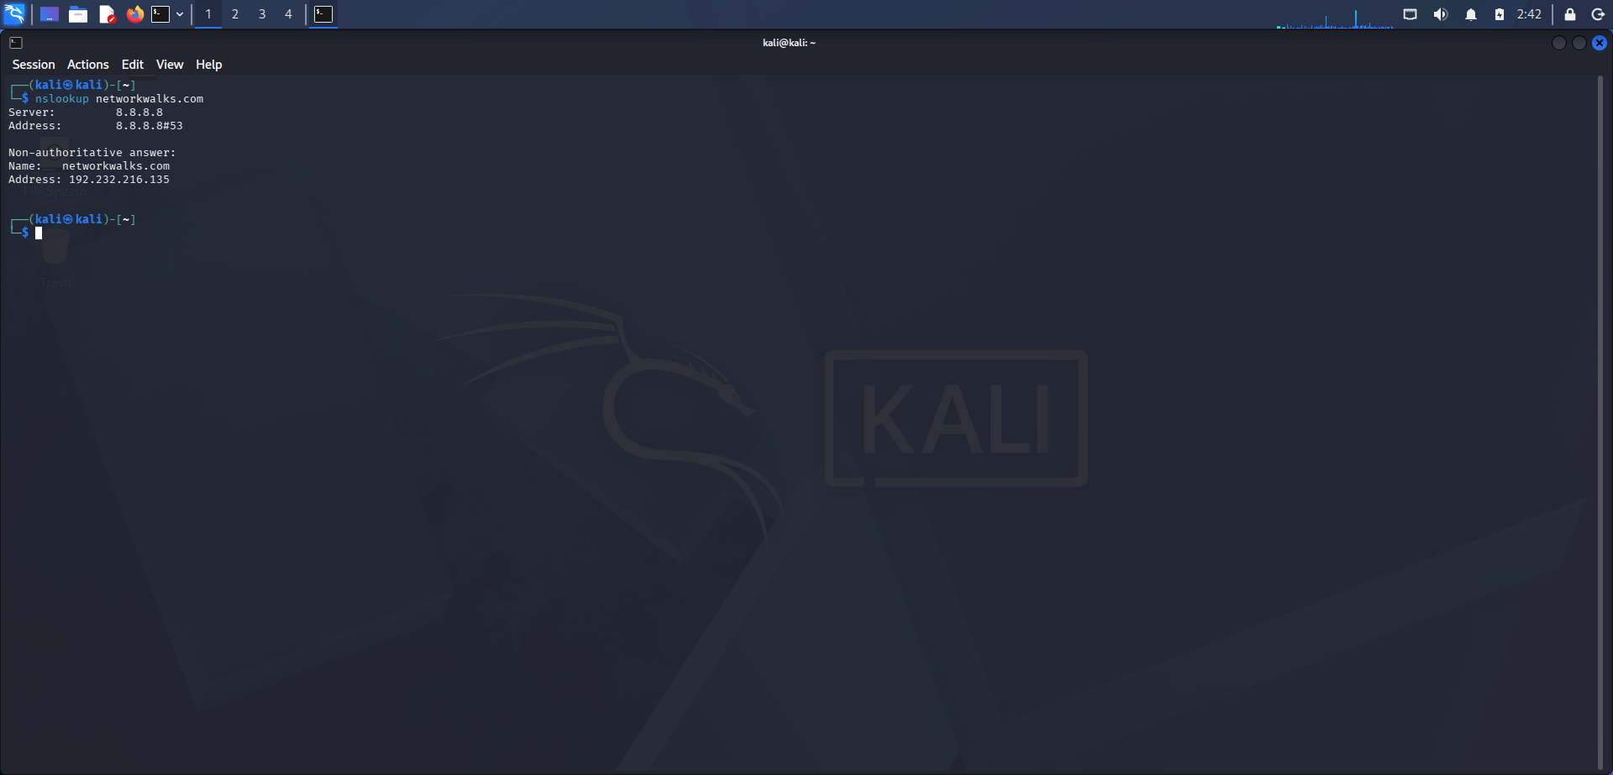 | Output file  ┌──(kali㉿kali)-[~]  └─$ nslookup networkwalks.com  Server: 8.8.8.8  Address: 8.8.8.8#53  Non-authoritative answer:  Name: networkwalks.com  Address: 192.232.216.135  ┌──(kali㉿kali)-[~]  └─$
Task 4
Screenshot  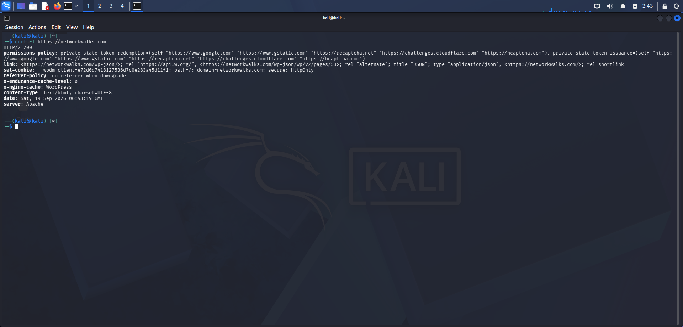 | Output file  ┌──(kali㉿kali)-[~]  └─$ curl -I https://networkwalks.com  HTTP/2 200  permissions-policy: private-state-token-redemption=(self "https://www.google.com" "https://www.gstatic.com" "https://recaptcha.net" "https://challenges.cloudflare.com" "https://hcaptcha.com"), private-state-token-issuance=(self "https://www.google.com" "https://www.gstatic.com" "https://recaptcha.net" "https://challenges.cloudflare.com" "https://hcaptcha.com")  link: <https://networkwalks.com/wp-json/>; rel="https://api.w.org/", <https://networkwalks.com/wp-json/wp/v2/pages/53>; rel="alternate"; title="JSON"; type="application/json", <https://networkwalks.com/>; rel=shortlink  set-cookie: __wpdm_client=e72d0d7418127536d7c0e283a45d11f1; path=/; domain=networkwalks.com; secure; HttpOnly  referrer-policy: no-referrer-when-downgrade  x-endurance-cache-level: 0  x-nginx-cache: WordPress  content-type: text/html; charset=UTF-8  date: Sat, 19 Sep 2026 06:43:19 GMT  server: Apache  ┌──(kali㉿kali)-[~]  └─$
Task 5
Screenshot  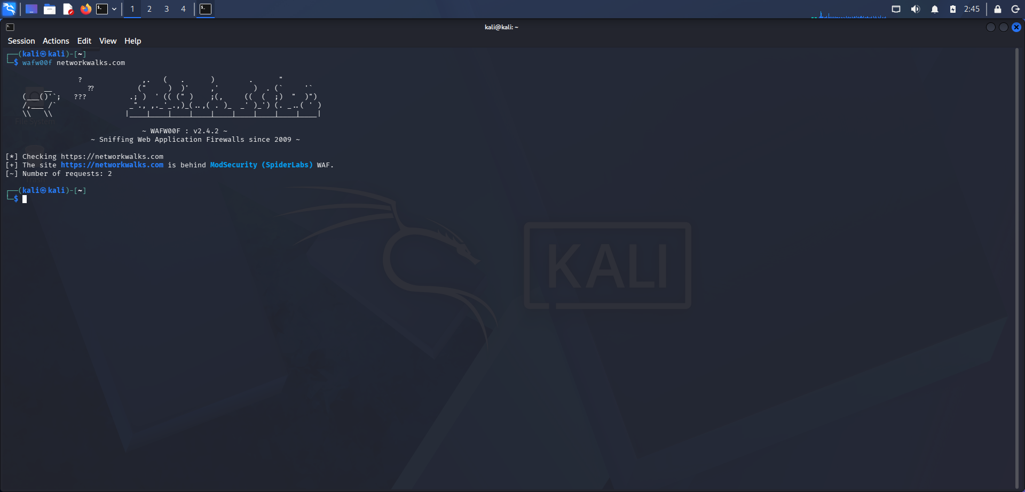 | Output file  ┌──(kali㉿kali)-[~]  └─$ wafw00f networkwalks.com  ? ,. ( . ) . "  __ ?? (" ) )' ,' ) . (` '`  (___()'`; ??? .; ) ' (( (" ) ;(, (( ( ;) " )")  /,___ /` _"., ,._'_.,)_(..,( . )_ _' )_') (. _..( ' )  \\ \\ |____|____|____|____|____|____|____|____|____|  ~ WAFW00F : v2.4.2 ~  ~ Sniffing Web Application Firewalls since 2009 ~  [*] Checking https://networkwalks.com  [+] The site https://networkwalks.com is behind ModSecurity (SpiderLabs) WAF.  [~] Number of requests: 2  ┌──(kali㉿kali)-[~]  └─$
Task 6
Screenshot  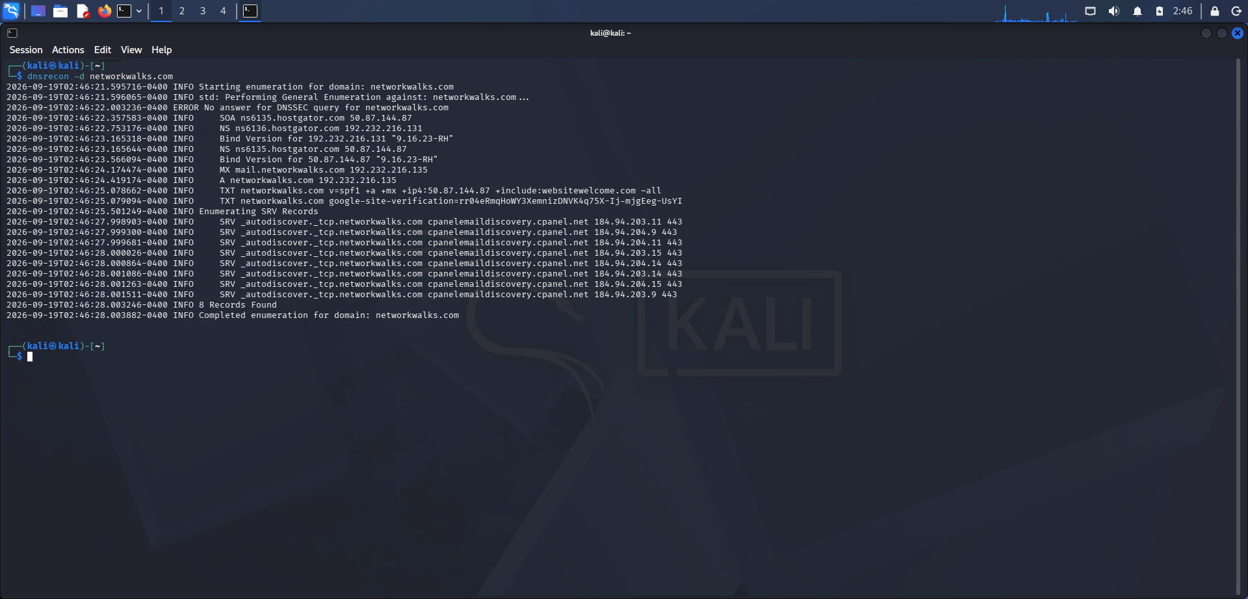 | Output file  ┌──(kali㉿kali)-[~]  └─$ dnsrecon -d networkwalks.com  2026-09-19T02:46:21.595716-0400 INFO Starting enumeration for domain: networkwalks.com  2026-09-19T02:46:21.596065-0400 INFO std: Performing General Enumeration against: networkwalks.com...  2026-09-19T02:46:22.003236-0400 ERROR No answer for DNSSEC query for networkwalks.com  2026-09-19T02:46:22.357583-0400 INFO SOA ns6135.hostgator.com 50.87.144.87  2026-09-19T02:46:22.753176-0400 INFO NS ns6136.hostgator.com 192.232.216.131  2026-09-19T02:46:23.165318-0400 INFO Bind Version for 192.232.216.131 "9.16.23-RH"  2026-09-19T02:46:23.165644-0400 INFO NS ns6135.hostgator.com 50.87.144.87  2026-09-19T02:46:23.566094-0400 INFO Bind Version for 50.87.144.87 "9.16.23-RH"  2026-09-19T02:46:24.174474-0400 INFO MX mail.networkwalks.com 192.232.216.135  2026-09-19T02:46:24.419174-0400 INFO A networkwalks.com 192.232.216.135  2026-09-19T02:46:25.078662-0400 INFO TXT networkwalks.com v=spf1 +a +mx +ip4:50.87.144.87 +include:websitewelcome.com ~all  2026-09-19T02:46:25.079094-0400 INFO TXT networkwalks.com google-site-verification=rr04eRmqHoWY3XemnizDNVK4q75X-Ij-mjgEeg-UsYI  2026-09-19T02:46:25.501249-0400 INFO Enumerating SRV Records  2026-09-19T02:46:27.998903-0400 INFO SRV _autodiscover._tcp.networkwalks.com cpanelemaildiscovery.cpanel.net 184.94.203.11 443  2026-09-19T02:46:27.999300-0400 INFO SRV _autodiscover._tcp.networkwalks.com cpanelemaildiscovery.cpanel.net 184.94.204.9 443  2026-09-19T02:46:27.999681-0400 INFO SRV _autodiscover._tcp.networkwalks.com cpanelemaildiscovery.cpanel.net 184.94.204.11 443  2026-09-19T02:46:28.000026-0400 INFO SRV _autodiscover._tcp.networkwalks.com cpanelemaildiscovery.cpanel.net 184.94.203.15 443  2026-09-19T02:46:28.000864-0400 INFO SRV _autodiscover._tcp.networkwalks.com cpanelemaildiscovery.cpanel.net 184.94.204.14 443  2026-09-19T02:46:28.001086-0400 INFO SRV _autodiscover._tcp.networkwalks.com cpanelemaildiscovery.cpanel.net 184.94.203.14 443  2026-09-19T02:46:28.001263-0400 INFO SRV _autodiscover._tcp.networkwalks.com cpanelemaildiscovery.cpanel.net 184.94.204.15 443  2026-09-19T02:46:28.001511-0400 INFO SRV _autodiscover._tcp.networkwalks.com cpanelemaildiscovery.cpanel.net 184.94.203.9 443  2026-09-19T02:46:28.003246-0400 INFO 8 Records Found  2026-09-19T02:46:28.003882-0400 INFO Completed enumeration for domain: networkwalks.com  ┌──(kali㉿kali)-[~]  └─$

HARVESTER
theHarvester -h
Read proxies.yaml from /etc/theHarvester/proxies.yaml
*******************************************************************
* _ _ _ *
* | |_| |__ ___ /\ /\__ _ _ ____ _____ ___| |_ ___ _ __ *
* | __| _ \ / _ \ / /_/ / _` | '__\ \ / / _ \/ __| __/ _ \ '__| *
* | |_| | | | __/ / __ / (_| | | \ V / __/\__ \ || __/ | *
* \__|_| |_|\___| \/ /_/ \__,_|_| \_/ \___||___/\__\___|_| *
* *
* theHarvester 4.10.1 *
* Coded by Christian Martorella *
* Edge-Security Research *
* cmartorella@edge-security.com *
* *
*******************************************************************
usage: theHarvester [-h] -d DOMAIN [-l LIMIT] [-S START] [-p] [-s] [--screenshot SCREENSHOT] [-e DNS_SERVER] [-t] [-r [DNS_RESOLVE]] [-n] [-c] [-f FILENAME] [-w WORDLIST] [-a] [-q] [-b SOURCE]

theHarvester is used to gather open source intelligence (OSINT) on a company or domain.

options:
-h, --help show this help message and exit
-d, --domain DOMAIN Company name or domain to search.
-l, --limit LIMIT Limit the number of search results, default=500.
-S, --start START Start with result number X, default=0.
-p, --proxies Use proxies for requests, enter proxies in proxies.yaml.
-s, --shodan Use Shodan to query discovered hosts.
--screenshot SCREENSHOT
Take screenshots of resolved domains specify output directory: --screenshot output_directory
-e, --dns-server DNS_SERVER
DNS server to use for lookup.
-t, --take-over Check for takeovers.
-r, --dns-resolve [DNS_RESOLVE]
Perform DNS resolution on subdomains with a resolver list or passed in resolvers, default False.
-n, --dns-lookup Enable DNS server lookup, default False.
-c, --dns-brute Perform a DNS brute force on the domain.
-f, --filename FILENAME
Save the results to an XML and JSON file.
-w, --wordlist WORDLIST
Specify a wordlist for API endpoint scanning.
-a, --api-scan Scan for API endpoints.
-q, --quiet Suppress missing API key warnings and reading the api-keys file.
-b, --source SOURCE baidu, bevigil, bitbucket, brave, bufferoverun, builtwith, censys, certspotter, chaos, commoncrawl, criminalip, crtsh, dehashed, dnsdumpster, duckduckgo, fofa, fullhunt, github-code, gitlab, hackertarget,
haveibeenpwned, hudsonrock, hunter, hunterhow, intelx, leakix, leaklookup, netlas, onyphe,
subdomaincenter, subdomainfinderc99, thc, threatcrowd, tomba, urlscan, venacus, virustotal,
┌──(kali㉿kali)-[~]
└─$ theHarvester -d microsoft.com -l 1000 -b baidu
Read proxies.yaml from /etc/theHarvester/proxies.yaml
*******************************************************************
* _ _ _ *
* | |_| |__ ___ /\ /\__ _ _ ____ _____ ___| |_ ___ _ __ *
* | __| _ \ / _ \ / /_/ / _` | '__\ \ / / _ \/ __| __/ _ \ '__| *
* | |_| | | | __/ / __ / (_| | | \ V / __/\__ \ || __/ | *
* \__|_| |_|\___| \/ /_/ \__,_|_| \_/ \___||___/\__\___|_| *
* *
* theHarvester 4.10.1 *
* Coded by Christian Martorella *
* Edge-Security Research *
* cmartorella@edge-security.com *
* *
*******************************************************************

[*] Target: microsoft.com

[*] Searching Baidu.

[*] No IPs found.

[*] Emails found: 4
----------------------
,contact@microsoft.com
,support@microsoft.com
info@microsoft.com
viva-noreply@microsoft.com

[*] No people found.

[*] Hosts found: 11
---------------------
account.microsoft.com
appsource.microsoft.com
docs.microsoft.com
hxd.research.microsoft.com
i.msdn.microsoft.com
learn.microsoft.com
social.microsoft.com
speech.microsoft.com
sqm.microsoft.com
support.microsoft.com
xref.docs.microsoft.com

